Project Planning Phase
Project Planning Template (Product Backlog, Sprint Planning, Stories, Story points)

Date | 29.09.2026
Team ID | 6AP3D7136F290BE8A6B32917
Project Name | AI FAQ ASSISTANT API
Maximum Marks | 5 Marks

Product Backlog, Sprint Schedule, and Estimation
Sprint | Functional Requirement (Epic) | User Story Number | User Story / Task | Story Points | Priority | Team Members
Sprint-1 | User Authentication | USN-1 | As a user, I can register using my name, email and password. | 3 | High | [Member Names]
Sprint-1 | User Authentication | USN-2 | As a user, I can login using my email and password and receive a JWT token. | 3 | High | [Member Names]
Sprint-1 | User Authentication | USN-3 | As an authenticated user, I can access my profile information. | 2 | Medium | [Member Names]
Sprint-2 | FAQ Management | USN-4 | As an authenticated user, I can create a new FAQ with question, answer and category. | 3 | High | [Member Names]
Sprint-2 | FAQ Management | USN-5 | As a public user, I can view all available FAQs. | 2 | High | [Member Names]
Sprint-2 | FAQ Management | USN-6 | As a public user, I can view an individual FAQ using its ID. | 2 | Medium | [Member Names]
Sprint-2 | FAQ Management | USN-7 | As an authenticated user, I can update my own FAQ records. | 3 | High | [Member Names]
Sprint-3 | FAQ Management | USN-8 | As an authenticated user, I can delete my own FAQ records. | 2 | High | [Member Names]
Sprint-3 | FAQ Search | USN-9 | As a user, I can search FAQs using keywords. | 3 | High | [Member Names]
Sprint-3 | AI Services | USN-10 | As an authenticated user, I can generate an AI-based answer for a question. | 5 | High | [Member Names]
Sprint-4 | AI Services | USN-11 | As an authenticated user, I can generate FAQ question-and-answer pairs from a topic using Gemini AI. | 5 | High | [Member Names]
Sprint-4 | Security & Validation | USN-12 | As a system, I can protect passwords using bcrypt and private APIs using JWT authentication. | 3 | High | [Member Names]
Sprint-4 | Testing & Error Handling | USN-13 | As a developer, I can test API operations and handle validation and server errors consistently. | 3 | Medium | [Member Names]

Project Tracker, Velocity & Burndown Chart
Sprint | Total Story Points | Duration | Sprint Start Date | Sprint End Date (Planned) | Story Points Completed | Sprint Release Date (Actual)
Sprint-1 | 8 | 6 Days | 01 Sep 2026 | 06 Sep 2026 | 8 | 06 Sep 2026
Sprint-2 | 12 | 6 Days | 07 Sep 2026 | 12 Sep 2026 | 12 | 12 Sep 2026
Sprint-3 | 10 | 6 Days | 14 Sep 2026 | 19 Sep 2026 | 10 | 19 Sep 2026
Sprint-4 | 11 | 6 Days | 21 Sep 2026 | 26 Sep 2026 | 11 | 26 Sep 2026

Total Story Points: 41

Velocity
Team velocity represents the number of story points completed during a sprint.
Average Velocity = Total Story Points Completed ÷ Number of Sprints
Average Velocity = 41 ÷ 4 = 10.25 story points per sprint

Burndown Chart
For the burndown chart, use the Sprint-1 to Sprint-4 story points above and show the remaining work decreasing as each sprint is completed.
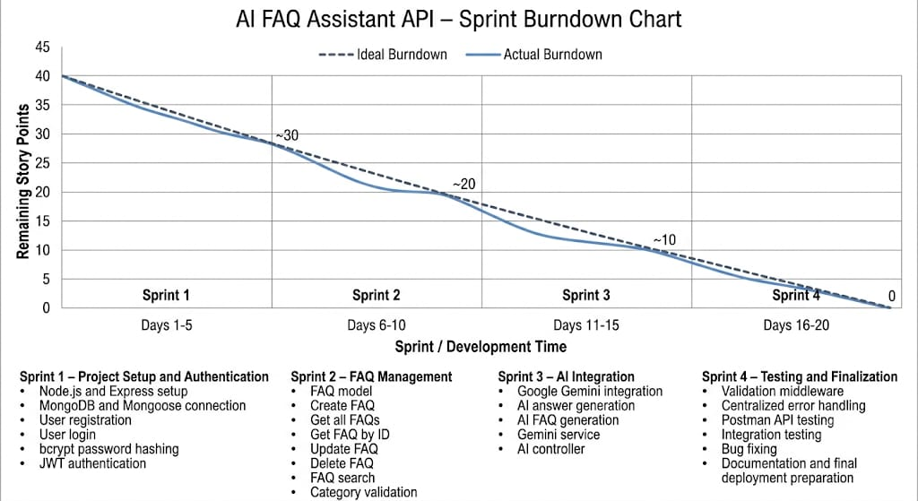
Charttitle:
AI FAQ Assistant API – Sprint Burndown Chart
This version is specifically based on the AI FAQ Assistant API you gave me—not your Student Feedback project.

